**Project 3 Proposal**

**Introduction**

Using the data uploaded to MongoDB, we will utilize D3.js to create 3 visualizations. The first wil compare two players (user selected from drop down). The second is a multi-line graph showing PER by position (user selects what position(s) to see). The third is a scatter plot showing player salaries (user selects the team).Create a html page to display all those visualizations.

**Database - MongoDB**

* Pull data from MongoDB (created from project 2)

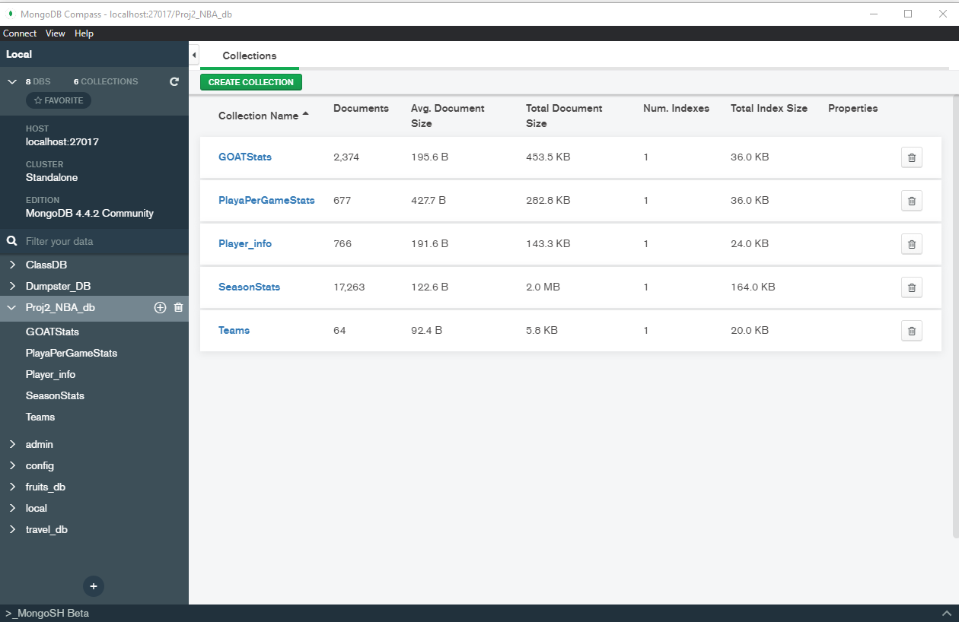

**Graph concepts:**

1. Versus bar graph
   1. Can include tooltip
   2. D3.js visuals -> I think this is better for this

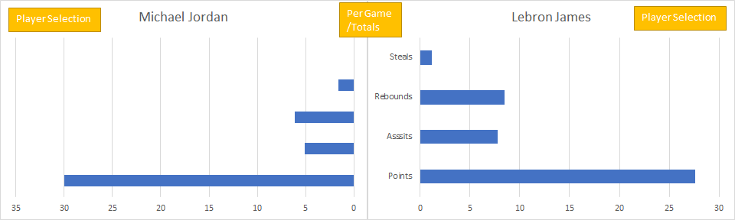

1. Multi line graph
   1. I like this one if we can make each position selectable, so you can look at one, two, three, four, or all the lines - Check box

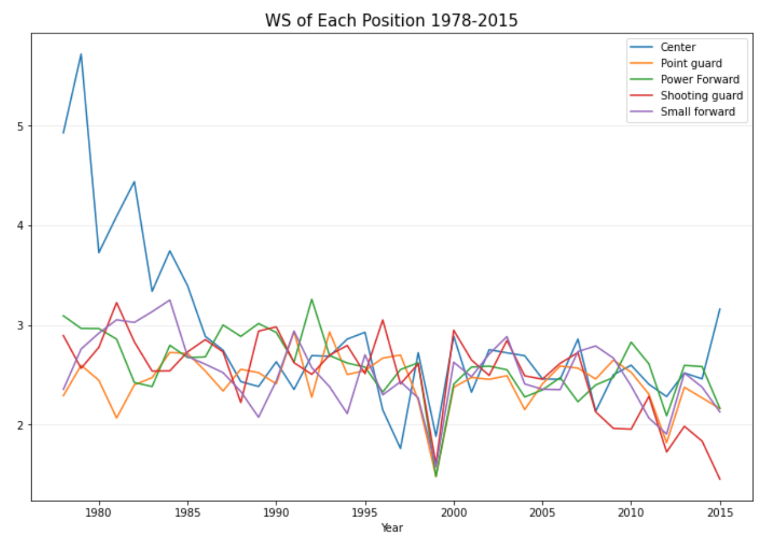

1. Salary Scatter plot
   1. Have team salary total in bar graph, select bar and create scatter plot with paler salaries

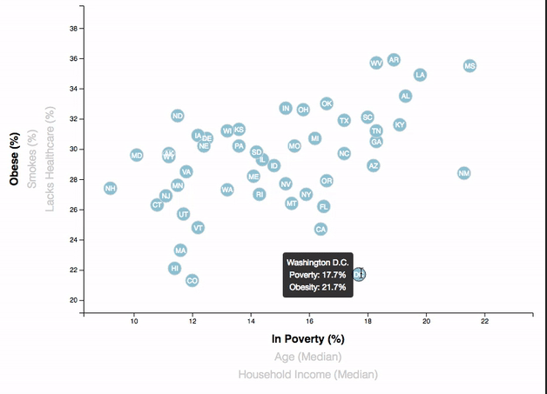

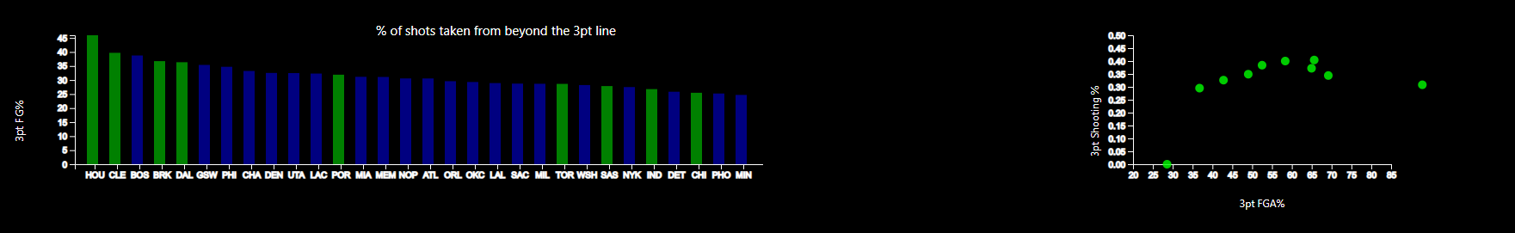

**Page sketch**

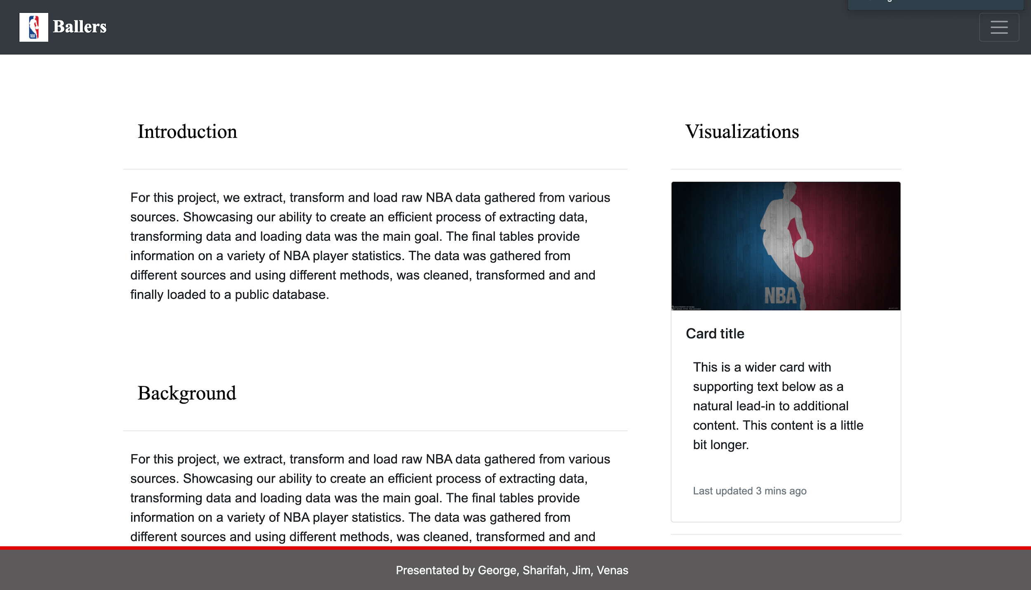

**Link to github repository**

<https://github.com/lovenalee/project3>